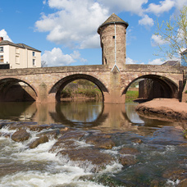

Monmouthshire NORTH MONTHLY UPDATE July 2026

LLANOVER WARD

Llanarth

REPORTS RECEIVED:

05/07/26 – a report has been received of a suspicious vehicle in Penyrhol.

08/07/26 – A report has been received of a rogue trader incident on Kemeys Road, who has dumped tarmac on a private lane then has asked the owners for payment.

11/07/26 – A report has been received of a highway disturbance where a bull has been reported walking on the road in Llanvaply. Officers attended and managed to get the animal back into a field.

14/07/26 – A report has been received of a theft of a John Deere Gator from Llanvair Grange Road.

23/07/26 – A report has been received of a two vehicle RTC on Clytha Road. No injuries sustained.

23/07/26 – a report has been received of a highway disturbance where a tree has fallen and blocked the road, near to the Chainbridge. MCC were contacted and they removed the obstruction.

- Llanarth = 11 calls have been received this month in relation to the hospital.

- A40 = 19 calls have been received this month in relation to the carriageway ranging from broken down vehicles and debris in the road.

- B4598: 2 calls have been received this month in relation to the carriageway ranging from broken down vehicles and debris in the road.

- A4042: 3 calls have been received this month in relation to the carriageway ranging from broken down vehicles and debris in the road.

Should you wish to report anything, then please do so through our 101 non-emergency number, our website, social media or 999 for an emergency.

ACTION PLANS:

- North Monmouthshire Burglaries
- 20mph Speed Limits

Monmouthshire NORTH Neighbourhood POLICING TEAM

@gwent.pnn.police.uk

Gwent Contact Page – To report incidents online.
Contact us | Gwent Police

