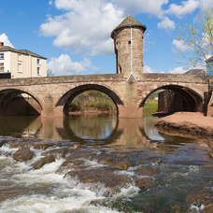

Monmouthshire NORTH MONTHLY UPDATE April 2026

LLANOVER WARD

Llanarth

REPORTS RECEIVED:

04/04/26 – A report has been received of a suspicious vehicle driving slowly passed farm buildings in Coed Morgan.

06/04/26 – A report has been received of a possible abandon vehicle in Llanover.

10/04/26 – A report has been received of a possible abandon vehicle in Llanover, MCC have been contacted to arrange recovery.

12/04/26 – A report has been received of a highway disruption, where a tree has come down and blocking Kemeys road.

20/04/26 – A report has been received of a suspicious vehicle parked in Llanvihangel Gobion. Officers attended but the vehicle had moved prior to their arrival.

- Llanarth = 11 calls have been received this month in relation to the hospital.

- A40 = 23 calls have been received this month in relation to the carriageway ranging from broken down vehicles and debris in the road.

- B4598: 2 calls have been received this month in relation to the carriageway ranging from broken down vehicles and debris in the road.

- A4042: 3 calls have been received this month in relation to the carriageway ranging from broken down vehicles and debris in the road.

- The Mont, Pen-y-Parc and Ty Gwair which are residential children’s care homes, 32 reports of missing children and anti-social behaviour. All children have been located and returned to the home.

- The Mont and Ty Gwair which are residential children’s care homes, reports of missing children and anti-social behaviour. All children have been located and returned to the home.

Should you wish to report anything, then please do so through our 101 non-emergency number, our website, social media or 999 for an emergency.

ACTION PLANS:

- North Monmouthshire Burglaries
- 20mph Speed Limits

Monmouthshire NORTH Neighbourhood POLICING TEAM

@gwent.pnn.police.uk

Gwent Contact Page – To report incidents online.
Contact us | Gwent Police

