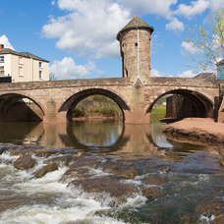

Monmouthshire NORTH MONTHLY UPDATE March 2026

LLANOVER WARD

Llanarth

REPORTS RECEIVED:

10/03/26 – Whilst officers were out on patrol on Cripple Creek Road, they came across a vehicle without valid insurance. Officers stopped and seized the vehicle.

19/03/26 – A report has been received of a two vehicle RTC in Penpergwm, no injuries sustained.

19/03/26 – A report has been received in relation to ongoing nuisance behaviour from the nearby children’s home in Bryngwyn.

21/03/26 – A report has been received of a highway disturbance, where a bale of hay has fallen into the road.

26/03/26 – A report has been received of a two vehicle RTC in Llanvapley, no injuries sustained.

- Llanarth = 8 calls have been received this month in relation to the hospital.

- A40 = 5 calls have been received this month in relation to the carriageway ranging from broken down vehicles and debris in the road.

- B4598: 3 calls have been received this month in relation to the carriageway ranging from broken down vehicles and debris in the road.

- A4042: 9 calls have been received this month in relation to the carriageway ranging from broken down vehicles and debris in the road.

- The Mont and Ty Gwair which are residential children’s care homes, 10 reports of missing children and anti-social behaviour. All children have been located and returned to the home.

Should you wish to report anything, then please do so through our 101 non-emergency number, our website, social media or 999 for an emergency.

ACTION PLANS:

- North Monmouthshire Burglaries
- 20mph Speed Limits

Monmouthshire NORTH Neighbourhood POLICING TEAM

@gwent.pnn.police.uk

Gwent Contact Page – To report incidents online.
Contact us | Gwent Police

